Quiz 9: Heat and Gases

Questions 1-4 refer to the following Diagram.
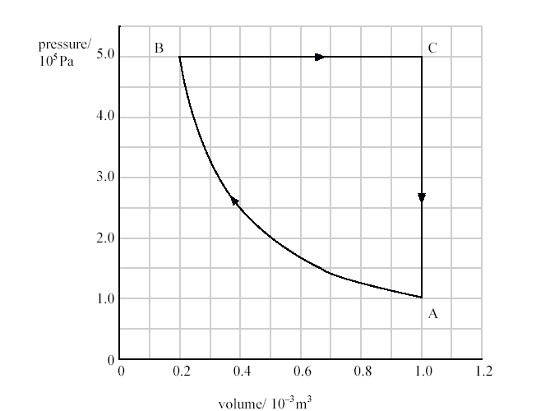
- In which process is no work done?
  - A®B
  - B®C
  - C®A
  - B®C®A
  - A®B®C®A

- The temperature of the gas at point A is 200K. What is the approximate number of molecules in the container?
  - 3 x 10²² molecules
  - 3 x 10²⁰ molecules
  - 6 x 10⁻² molecules
  - 3 x 10⁻²³ molecules
  - It is impossible to tell with knowing the molar mass of the gas.

- If the temperature at point A is 200K, What is the temperature of the gas at point C?
  - 8 K
  - 40 K
  - 250 K
  - 500 K
  - 1000 K

- What is the work done in the process B®C?
  - 0 J
  - 4 J
  - 8 x 10² J
  - 2 x 10³ J
  - 4 x 10³ J

- The specific heat of iron is approximately 450 J/kg°C. If 27,000J are used to heat a mass of iron from 5°C to 25°C, what is the mass of the Iron?
  - 1 kg
  - 2 kg
  - 3 kg
  - 4 kg
  - 5 kg

- The specific heat of Aluminum is approximately twice the specific heat of iron. Two cups have an identical amount of water in them at the same temperature. A small ball of aluminum and a small ball of iron, both of the same mass, are heated to a temperature of 90°C. The balls are then dropped into the cups of water, one in each cup. 30 seconds after the balls are dropped, the temperature of the water will be greater in which cup?
  - The cup with the aluminum ball.
  - The cup with the steel ball.
  - Both cups of water will be at the same temperature.
  - It is impossible to tell without knowing the initial temperature of the water.
  - It is impossible to tell without knowing the mass of the water in each cup.

- 100 kg of ice have a temperature of -25°C. 1 kg of water has a temperature of 13°C. Heat will flow from -
  - the water into the ice because heat always flows from hot to cold.
  - The water into the ice because the water is a fluid and the ice is not.
  - the ice into the water because the ice has a greater internal energy.
  - From the ice into the water because the ice has a greater entropy, and entropy always increases.
  - no heat will flow because the ice and water are in thermal equilibrium.

- The pressure of a monatomic ideal gas is doubled, while the volume is decreased to half of the original. By what factor does the internal energy of the gas change?
  - 1/4
  - 1/2
  - 1
  - 2
  - 4

- 5000 J of heat are added to 3 x 10²³ molecules of a gas. The gas does 1000J of work. What is the change in internal energy of the gas?
  - 1.333 x 10⁻²³ J
  - 4000 J
  - 5000 J
  - 6000 J
  - 1.8 x 10²⁴ J

- The temperature of a gas is raised from 200°C to 400°C. If the volume remains constant, the pressure will -
  - increase by a factor of less than 2.
  - increase by a factor of 2.
  - increase by a factor of greater than 2.
  - decrease by a factor of less than 2.
  - decrease by a factor of 2.

